Kyle Perra

Dr. Jagodzinski

CS 460

**Design Document Three**

**Description**

My application (which will be for Android OS) will contain two views: a ‘Welcome’ view and an ‘Account Settings’ view. Initially, a user will be sent to the Welcome view, where they will be prompted to enter their credentials necessary (username and password) to either ‘log in’ to the system, or create a new account for the system. My app will utilize a database by first containing the credential information the user chooses when they create an account. When attempting to log in (in the Welcome view), the database will be queried as to whether the input account exists with error handling for non-existent accounts or incorrect input. In the Account Settings page, a user will be allowed to alter their information in the database, by first entering their current credentials and then their updated field - this process will query the database (with error handling), and if the credentials match then their database entry will be updated.

**Sketch Layout**

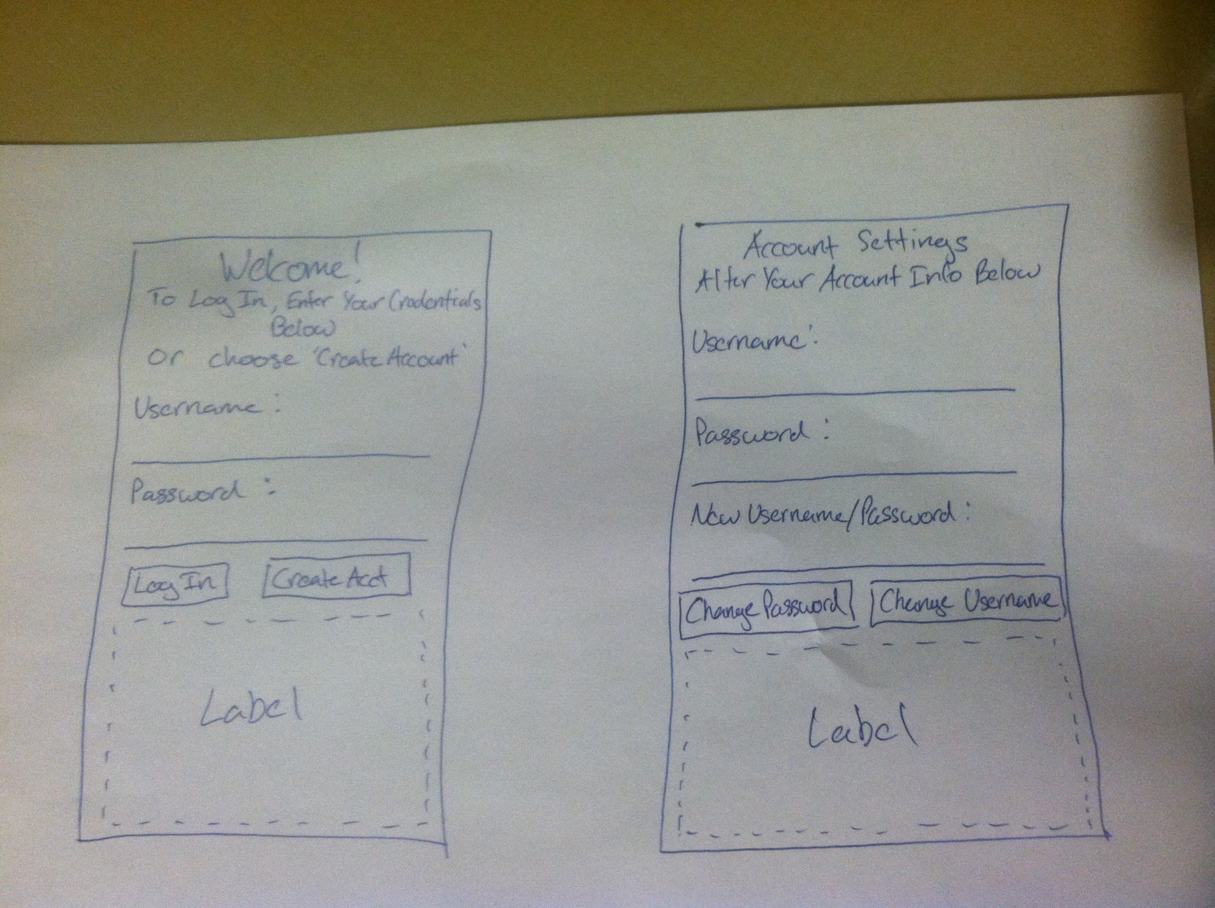

**Proper UI Design**

My application follows well with proper UI design (as described through the four pillars of Good UI Design and 8 golden rules to app design, as lectured) for its simplified look, wording, support of internal locus of control and universal usability. The app will have been well tested by time of release, as well. Moreover, the UI interface takes on a minimal layout, wherein each created element is functionally necessary and not wasting any of the minimal available space; my app components follow similar wordings so as to promote user friendliness; my app supports decision making by the user at the beginning of each app process.

**XML**

<AccountIdentificationApp>

<WelcomeView>

<label>Welcome!</label>

<label>To Log In, Enter Your Credentials Below</label>

<label>Otherwise, Create A New Account</label>

<label>Username:</label>

<textField>UserNameInput</textField>

<label>Password:</label>

<textField>UserPassInput</textField>

<button>Log In</button>

<button>Create Account</button>

<label>Empty</label>

</WelcomeView>

<AccountSettingsView>

<label>Account Settings</label>

<label>Alter Your Account Information Below</label>

<label>Username:</label>

<textField>userNameInput</textField>

<label>Password:</label>

<textField>userPassInput</textField>

<button>Change Username</button>

<button>Change Password</button>

<label>Empty</label>

</AccountSettingsView>

<AccountIdentificationApp>

**Control Flow Diagram**

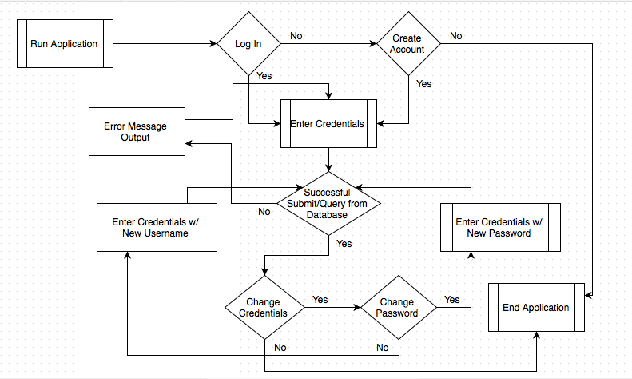

**Data Flow Diagram**

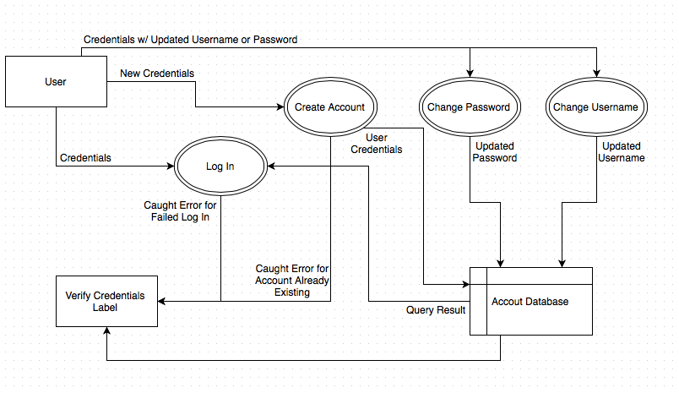

**Database Design**

**Name: AccountDB**

**Table Name: Accts**

**Columns: ID; UserName; UserPassword**

**Column Types: Integer; String; String**